Low Level Design (fUND TRANSFER MODULE)

Project Code | Team1
Project Name | Banking System

Prepared/Modified by | Role | Date of Preparation
Apurva Agarwal,Rishav Halder | Software Engineer | 15/10/2018
Reviewed by | Role | Date of Review
Purav Nagda,Harshi Sirohi | Software Engineer | 17/10/2018
Approved by | Role | Date of Approval
Circulation List |  | Version Number of the template:1.0
Version Number

Table of Contents

1. Description Of The Unit 3
2. References 4
3. Dependencies / Assumptions 5
4. Class Diagrams 6
5. Sequence Diagrams 7
6. Design Components 8
6.1 List Of UI Components 8
6.2 List Of Design Classes 8
7. Re-Usable Routines/Components 9
8. Messages 10
9. Configuration Files 11
10. Crud Matrix Table 12
11. Data Mapping Matrix 13
12. Action Flow Matrix 14
13. Stored Procedures 15
14. Program Specification / Pseudo Code 16
REVISION HISTORY OF THE WORK PRODUCT 17

Description Of The Unit

The fund transfer module allows the user to transfer fund to the other account of same user or to transfer fund in other user account.

Checking whether the credit and debit account no. is not same. Account balance should not be less than transfer amount. Otherwise the inappropriate messages are displayed.

After crediting and debiting the money in both the accounts, the details are inserted into the database. The admin and user can view the transaction details after fund transferring.

References

Reference | Description
Repository reference | Is on MongoDB
Class Diagram | /Project Documents/Design Documents/HLD/Class Diagrams
URS | /Project Documents/Requirements/Case Study/Ecommerce-grp1 and grp3.doc
UTP | /Project Documents/Test Plan/UTP/Test Cases/AddProduct /UTP_AddProductModule.xlsm
DB Design | /Project Documents/Design Documents/HLD/DB Design/ FUND_TRANSFER_DBDESIGN

Dependencies / Assumptions

Dependencies:
Account number should exist.

Assumptions:
The user details are stored in the database and the user is already logged in.

Class Diagrams

Class Diagram

Sequence Diagrams

Sequence Diagram
NA

Design Components

List Of UI Components
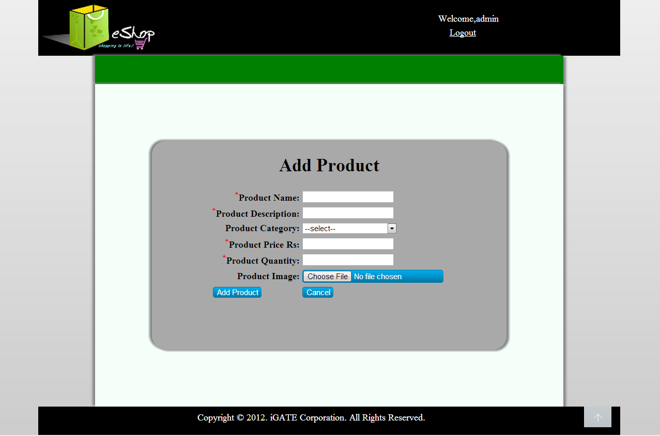

List Of Design Classes
Sr. No. | LLD Name | Class Name | Method Name | Method Description
1 | Fund Transfer Module | AccountMaster,FundTransfer,Transactions,UserTable | Appropriate getters and setters methods | Getters retrieve the property values and setters set the property values
2 | Fund Transfer Module | FundTransferController | fundTransfer( @RequestBody FundTransfer ft):String  insert(): String | Operation is performed for the existing users and accounts.  Details is inserted in the database.
3 | Fund Transfer Module | AccountMasterDao,TransactionDao,UserTableDao |  | Extends Mongo Repository.

Re-Usable Routines/Components

Re-Usable Routines/Components

- Database properties files
- Entities

Messages

#. | Type | Message Text
M1 | Error | Wrong User Name
M2 | Error | Account conflict! Unable to proceed due to same account number entered.
M3 | Error | Invalid Account Number
M4 | Error | Insufficient balance
M5 | Error | Account Number does not exists
M6 | Error | Wrong Transaction Password

Configuration Files

File Name | Path | Description
application.properties | MicroBanking-master/FundTransfer/target/classes | To configure database connection.
pom.xml | /MicroBanking-master/FundTransfer | To configure the bean properties.

Crud Matrix Table

# | Table Name | Create | Read | Update | Delete
1. | AccountMaster | N | Y | N | N
2. | Transactions | N | Y | Y | N
3. | UserTable | N | Y | Y | N

Data Mapping Matrix

Sr. No. | Screen Label | Field Source | Data Type | Max Length | Data Flow | Mandatory
1 | fromAc | com.cg.bs.ft.FundTransfer.entities. FundTransfer | int | 10 | PM→D | Yes
2 | userId | com.cg.bs.ft.FundTransfer.entities. FundTransfer | int | 10 | PM→D | Yes
3 | toAc | com.cg.bs.ft.FundTransfer.entities. FundTransfer | int | 20 | PM→D | Yes
4 | amt | com.cg.bs.ft.FundTransfer.entities. FundTransfer | int | 10 | PM→D | Yes
5 | tnxPassword | com.cg.bs.ft.FundTransfer.entities. FundTransfer | Varchar | 20 | PM→D | Yes

Legend
D → PM (Database to Postman)
PM → D (Postman to Database)
PM (Postman)

Action Flow Matrix

Sr. No. | Action
1 | Run Eureka Server, Run BankingClient, Run FundTransfer
2 | Copy the link from eureka to Postman.
3 | Run the URL on the postman.

Stored Procedures

# | Stored Procedure Name  (with Description) | Input/Out Parameters | Type | Size
1. | NA | NA | NA | NA

Program Specification / Pseudo Code

<ACTION :ADD_CLICK >

Pseudo Code:
- Client Side Scripting:
None

- Server Side Scripting:
BEGIN
Call prepareAdd(Model model) in Controller class
Navigate to add page
END

14. 2 <ACTION: FundTransfer>

Pseudo Code:

- Client Side Scripting:

If userid does not exist
return "Wrong User Name";

if from account and to account is not equal
return Account conflict

if account does not exist
return Invalid Account Number

If balance is not sufficient
return Insufficient balance in Account No:

if password is incorrect
return "Wrong Transaction Password";

td.save(tnxDebit);
- //credit tnx
- tnxId++; tnxCredit= new Transactions(tnxId, "Fund Transfered from A/C No. "+ft.getFromAc(), "c", ft.getToAc(), ft.getAmt());
- td.save(tnxCredit);
- //update balance for to a/c
- fromAcDetails.setAcBalance(fromAcDetails.getAcBalance()-ft.getAmt());
- amd.save(fromAcDetails);
- //update balance for to a/c
- toAcDetails.setAcBalance(toAcDetails.getAcBalance()+ft.getAmt());
- amd.save(toAcDetails); Server Side Scripting:
BEGIN
Call processAddPage(@RequestParam("file") String filename,@ModelAttribute("Product") @Valid Product product,BindingResult result,Model model) in Controller class in Presentation Layer
BEGIN
Call addProduct (Product product) in EshopBOImpl class in Service Layer
BEGIN
Call Call addProduct (Product product) in EshopDAOImpl class class in Data Access Layer
BEGIN
Create query for insert records into Product and Product_Image table
Return Integer value.
END
Return Integer value. to Service Layer
END
Return Integer value to Presentation Layer

END
IF successful navigate to home page
Else navigate to add page and show error.
END

14. 2 <ACTION: CANCEL_CLICK>

Pseudo Code:
1. Client Side Scripting:
None

2. Server Side Scripting:
BEGIN
Call prepareHomePage(Model model) in Controller class
Navigate to home page
END

REVISION HISTORY OF THE WORK PRODUCT

# | Date | Version # | Section Changed | Details of changes made | Approved By
1 | 15/10/2018 | 1.0 | LLD prepared | N/A
2 | 15/12/2018 | 1.1 | Reusable components,  Pseudo code | Reusable components added.  The pseudo code is modified as per the specified flow.
3 | 16/10/2018 | 1.2 | Reusable components,  References,  Data Mapping Matrix. | Reusable Components added.  File name with relative path is added in the references section.  The name of text boxes(screen label is changed).
4 | 17/10/2018 | 1.3 | Configuration files,UI Components | Paths of the configuration files is updated and UI components(Screen Shots) added.

